**Programming Assignment 2 Individual Classes and Objects**

Name: **Sai Karun Sandugula**

UD ID: 101691752

**Program 1:**

**Logic 1:**

// Logic for Combo Lock which asks for the user input if he wants to try again for re-entering the ticks

**Code:**

/*

* To change this license header, choose License Headers in Project Properties.

* To change this template file, choose Tools | Templates

* and open the template in the editor.

*/

package com.mycompany.myjavaproject;

import java.util.Scanner;

/**

*

* @author sai

*/

public class Combo {

private int currentValue = 0, secret1, secret2, secret3; //Declaration of secret numbers

private boolean position0 = true, position1 = false, position2 = false, position3 = false, openlock = false; //Initialization of positions and lock

public void setSecret1(int secret1) { //secret1 value is set

this.secret1 = secret1;

}

public void setSecret2(int secret2) { //secret2 value is set

this.secret2 = secret2;

}

public void setSecret3(int secret3) { //secret3 value is set

this.secret3 = secret3;

}

public void reset() { //resets the dial so that all the secret numbers points to 0

position0 = true;

position1 = false;

position2 = false;

position3 = false;

}

public void turnLeft(int ticks) { //turn the dial by a given number of ticks to the left

if (position1 == true) {

currentValue = currentValue - (40 - ticks);

if (currentValue == this.secret2) {

position2 = true;

}

}

}

public void turnRight(int ticks) { //turn the dial by a given number of ticks to the right

if (position0) {

currentValue = (40 - ticks);

if (currentValue == this.secret1) {

position1 = true;

position0 = false;

}

} else {

currentValue = (40 - (ticks - currentValue));

if (currentValue == this.secret3) {

position3 = true;

}

}

}

public boolean isOpen() { //The lock opens if the user first turns it right to the first number in the combination, then left to the second, and then right to the third

if (position1 && position2 && position3) {

openlock = true;

System.out.println("Click! Lock is opened.");

} else {

openlock = false;

System.out.println("Oops! Lock refuses to open.");

}

return openlock;

}

public int getCurrentValue() { //returns current value

return currentValue;

}

public static void main(String[] args) {

Scanner inputScanner = new Scanner(System.in);

System.out.println("Enter first secret: ");

int secret1 = inputScanner.nextInt();

System.out.println("Enter second secret: ");

int secret2 = inputScanner.nextInt();

System.out.println("Enter third secret: ");

int secret3 = inputScanner.nextInt();

Combo combo = new Combo(); //object creation for accessing methods

combo.setSecret1(secret1);

combo.setSecret2(secret2);

combo.setSecret3(secret3);

String c = "";

do {

combo.reset(); //reset method is called so that all the secret numbers points to 0

System.out.println("Enter the 1st # of ticks (to the right): ");

int firstTick = inputScanner.nextInt();

System.out.println("Enter the 2nd # of ticks (to the left): ");

int secondTick = inputScanner.nextInt();

System.out.println("Enter the 3rd # of ticks (to the right): ");

int thirdTick = inputScanner.nextInt();

combo.turnRight(firstTick);

combo.turnLeft(secondTick);

combo.turnRight(thirdTick);

Boolean isOpened = combo.isOpen();

if (!isOpened) {

System.out.println("Do you want to try again? ");

c = inputScanner.next();

} else {

c = "";

}

} while (c.equalsIgnoreCase("Y"));

}

}

**Sample Output:**

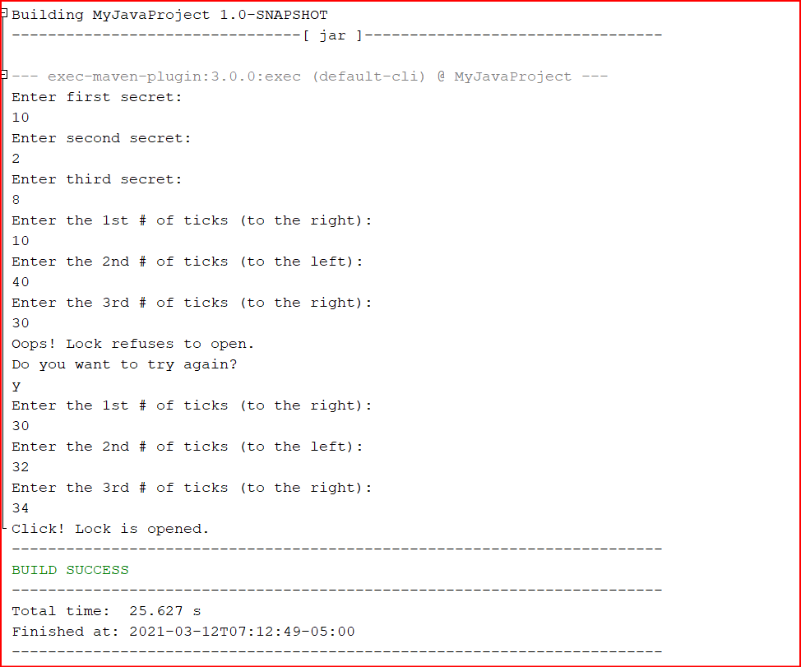

**Logic 2:**

// Logic for Combo Lock which repeatedly asks the user for the number of ticks to turn the dial (right-left-right), as long as the user does not input the correct combination.

**Code:**

/*

* To change this license header, choose License Headers in Project Properties.

* To change this template file, choose Tools | Templates

* and open the template in the editor.

*/

package com.mycompany.myjavaproject;

import java.util.Scanner;

/**

*

* @author sai

*/

public class LockTester {

private int currentValue = 0, secret1, secret2, secret3; //Declaration of secret numbers

private boolean position0 = true, position1 = false, position2 = false, position3 = false, openlock = false; //Initialization of positions and lock

public void setSecret1(int secret1) { //secret1 value is set

this.secret1 = secret1;

}

public void setSecret2(int secret2) { //secret2 value is set

this.secret2 = secret2;

}

public void setSecret3(int secret3) { //secret3 value is set

this.secret3 = secret3;

}

public void reset() { //resets the dial so that all the secret numbers points to 0

position0 = true;

position1 = false;

position2 = false;

position3 = false;

}

public void turnLeft(int ticks) { //turn the dial by a given number of ticks to the left

if (position1 == true) {

currentValue = currentValue - (40 - ticks);

if (currentValue == this.secret2) {

position2 = true;

}

}

}

public void turnRight(int ticks) { //turn the dial by a given number of ticks to the right

if (position0) {

currentValue = (40 - ticks);

if (currentValue == this.secret1) {

position1 = true;

position0 = false;

}

} else {

currentValue = (40 - (ticks - currentValue));

if (currentValue == this.secret3) {

position3 = true;

}

}

}

public boolean isOpen() { //The lock opens if the user first turns it right to the first number in the combination, then left to the second, and then right to the third

if (position1 && position2 && position3) {

openlock = true;

System.out.println("Click! Lock is opened.");

} else {

openlock = false;

System.out.println("Oops! Lock refuses to open.");

}

return openlock;

}

public int getCurrentValue() { //returns current value

return currentValue;

}

public static void main(String[] args) {

Scanner inputScanner = new Scanner(System.in);

System.out.println("Enter first secret: ");

int secret1 = inputScanner.nextInt();

System.out.println("Enter second secret: ");

int secret2 = inputScanner.nextInt();

System.out.println("Enter third secret: ");

int secret3 = inputScanner.nextInt();

Combo combo = new Combo(); //object creation for accessing methods

combo.setSecret1(secret1);

combo.setSecret2(secret2);

combo.setSecret3(secret3);

combo.reset(); //reset method is called so that all the secret numbers points to 0

System.out.println("Enter the 1st # of ticks (to the right): ");

int firstTick = inputScanner.nextInt();

System.out.println("Enter the 2nd # of ticks (to the left): ");

int secondTick = inputScanner.nextInt();

System.out.println("Enter the 3rd # of ticks (to the right): ");

int thirdTick = inputScanner.nextInt();

combo.turnRight(firstTick);

combo.turnLeft(secondTick);

combo.turnRight(thirdTick);

Boolean isOpened = combo.isOpen();

while (!isOpened) { //This loop will run until lock gets opened

combo.reset();

System.out.println("Enter the 1st # of ticks (to the right): ");

firstTick = inputScanner.nextInt();

System.out.println("Enter the 2nd # of ticks (to the left): ");

secondTick = inputScanner.nextInt();

System.out.println("Enter the 3rd # of ticks (to the right): ");

thirdTick = inputScanner.nextInt();

combo.turnRight(firstTick);

combo.turnLeft(secondTick);

combo.turnRight(thirdTick);

isOpened = combo.isOpen();

}

}

}

**Sample Output:**

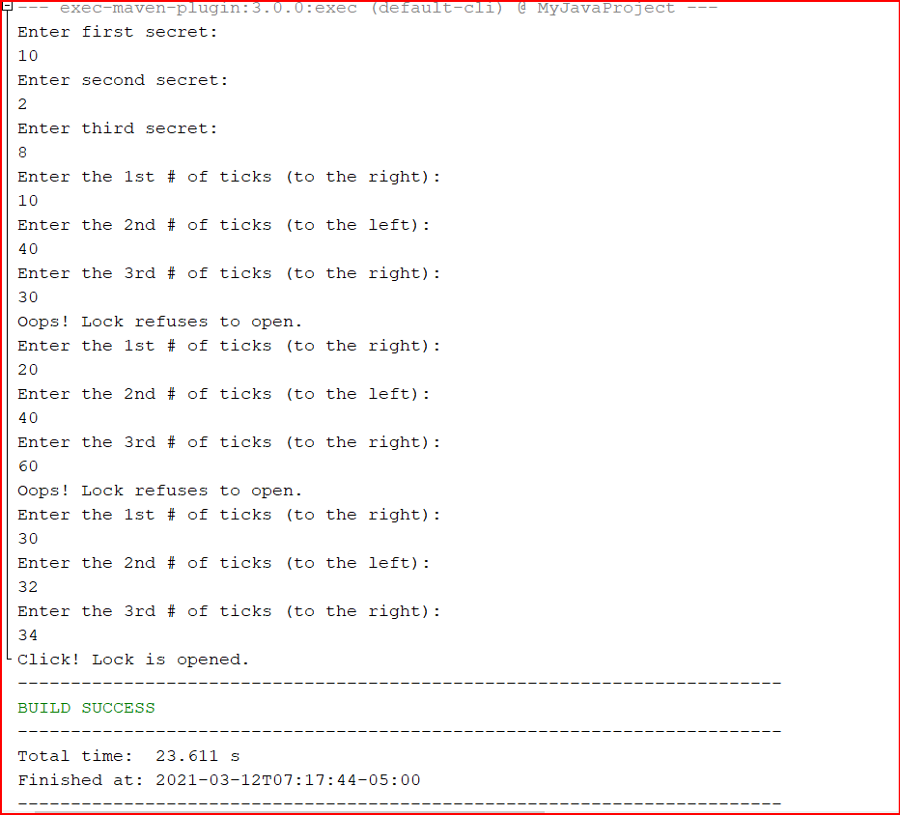

**Program 2:**

**Code:**

**//Voting Machine class**

/*

* To change this license header, choose License Headers in Project Properties.

* To change this template file, choose Tools | Templates

* and open the template in the editor.

*/

package com.mycompany.myjavaproject; //package declaration

/**

*

* @author sai

*/

public class VotingMachine { //class declaration

private int nd, nr; //nd defines number of votes for Democrates and nr defines number of votes for Republicans

public void clear() { //Initializes the number of votes for both parties to 0

this.nd = 0;

this.nr = 0;

}

public void voteDem() { //Number of votes for Democrates gets counted in this

this.nd++;

}

public void voteRep() { ////Number of votes for Repblicans gets counted in this

this.nr++;

}

public int getDemVotes() { //get the tally (number of votes) for the Democratic party

return this.nd;

}

public int getRepVotes() { //get the tally (number of votes) for the Republican party

return this.nr;

}

public String getWinner() { //returns the winner of the election based on the votes

if (nd > nr) {

return "Democrat";

} else if (nr > nd) {

return "Republican";

} else {

return "Tie";

}

}

}

**//Main Class**

/*

* To change this license header, choose License Headers in Project Properties.

* To change this template file, choose Tools | Templates

* and open the template in the editor.

*/

package com.mycompany.myjavaproject; //package declaration

/**

*

* @author sai

*/

public class Main1 { //class declaration

public static void main(String[] args) {

VotingMachine machine = new VotingMachine(); //object creation

for (int i = 1; i <= 1000; i++) {

if (Math.random() < 0.5) { //generates random number between 0 and 1

machine.voteDem(); //voteDem method is called

} else {

machine.voteRep(); //voteRep Method is called

}

}

System.out.print("The Democratic candidate won " + machine.getDemVotes() + " votes, ");

System.out.print("while the Republic candidate won " + machine.getRepVotes() + " votes, so...\n");

System.out.println("The " + machine.getWinner() + " candidate won the election!\n");

}

}

**Sample Output 1:**

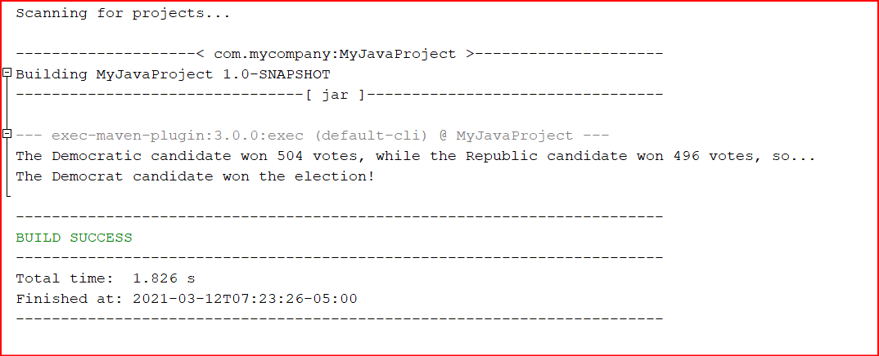

**Sample Output 2:**

